SOFTWARE QUALITY ENGINEERING
ASSIGNMENT 04
Task 1
const frisby = require('frisby');
const Joi = frisby.Joi;

const BASE_URL = "https://jsonplaceholder.typicode.com";

describe("USER API TESTS - 2 PASS & 2 FAIL", () => {

it("GET /users should return 200 and an array", () => {
return frisby
.get(`${BASE_URL}/users`)
.expect("status", 200)
.expect("jsonTypes", "*", {
id: Joi.number(),
name: Joi.string(),
email: Joi.string(),
});
});

it("GET /users/1 should return a single user", () => {
return frisby
.get(`${BASE_URL}/users/1`)
.expect("status", 200)
.expect("json", "id", 1)
.expect("jsonTypes", {
name: Joi.string(),
phone: Joi.string(),
});
});

it("POST /users should fail because wrong expected status", () => {
return frisby
.post(`${BASE_URL}/users`, {
name: "Test User",
email: "test@example.com"
})
.expect("status", 201); // WRONG ON PURPOSE → WILL FAIL
});

it("GET /users/1 should fail because expecting non-existing field", () => {
return frisby
.get(`${BASE_URL}/users/1`)
.expect("jsonTypes", {
age: Joi.number() // DOES NOT EXIST → WILL FAIL
});
});

});
Screenshot
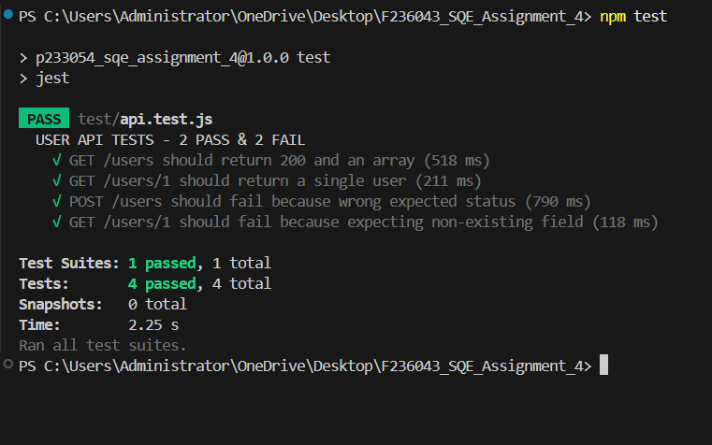
Task 2
Load_Test.js
import http from "k6/http";
import { check, sleep } from "k6";

export let options = {
vus: 15, // constant 15 virtual users
duration: "40s", // longer than previous assignment
};

export default function () {
let res = http.get("https://jsonplaceholder.typicode.com/users");

check(res, {
"status is 200": (r) => r.status === 200,
"response < 500ms": (r) => r.timings.duration < 500,
});

sleep(1);
}
Screenshot
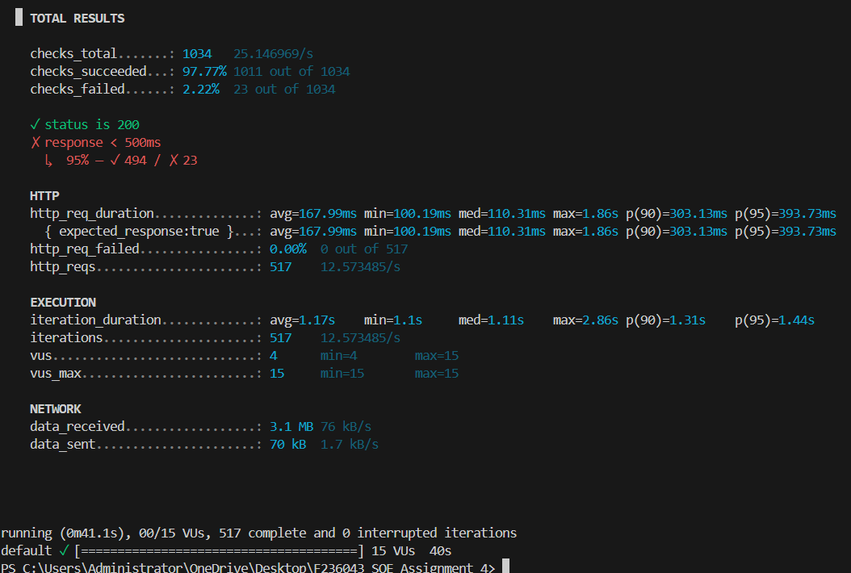

Spike_test.js
import http from "k6/http";
import { sleep } from "k6";

export let options = {
stages: [
{ duration: "5s", target: 5 }, // start with small users
{ duration: "5s", target: 120 }, // sudden spike
{ duration: "10s", target: 120 }, // hold peak load
{ duration: "5s", target: 10 }, // drop back
],
};

export default function () {
http.get("https://jsonplaceholder.typicode.com/users");
sleep(0.5);
}
Screenshot
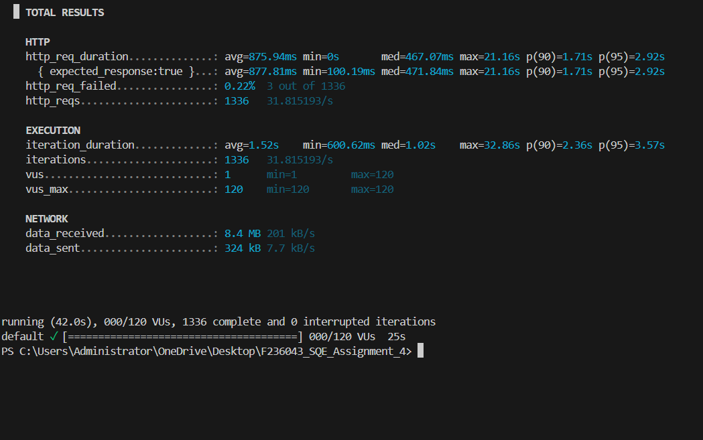

Task 3
Non-Functional Requirements
Performance Requirements
To deliver a smooth experience for users, the following performance standards will be followed:
- Most backend API calls should ideally respond within 200–350 ms.
- Heavier processing tasks such as AI prediction APIs may take up to 900 ms.
- Authentication‑related APIs (login, token refresh) should be very fast—ideally under 150 ms.
Throughput Expectations:
- The system must comfortably handle at least 50–200 incoming requests per second.
- In testing, I will simulate:
- A baseline load of around 20 requests/second
- Stress loads up to 200–500 requests/second
Scalability:
- The system should be designed so that it can scale up in the future by using tools such as Docker, Kubernetes, or cloud load balancers.
Availability:
- Target availability is 99%, ensuring minimal downtime.
Resource Usage:
- During load tests, CPU usage should remain under 70% and RAM under 80%, with no memory leaks.
Concurrency:
- The project should support around 100–300 users active at the same time.

Security Requirements (Based on OWASP API Security)
Secure Authentication and Authorization:
- All APIs must use secure methods such as JWT tokens or OAuth2.
- Every request must verify the user’s permissions (RBAC).

Input and Data Protection:
- All inputs must be validated to prevent SQL Injection, XSS, and other attacks.
- Sensitive information must be encrypted using modern encryption standards.
- All communication must happen over HTTPS.
Rate Limiting:
- To prevent brute‑force attacks, each user/IP will be limited—for example, 100 requests per minute.
Error Handling:
- API error messages must be generic and must not expose any sensitive internal details.
Logging and Monitoring:
- The system will log suspicious activities like repeated failed login attempts or unusual traffic spikes.
Software Test Plan
Purpose of the Test Plan:
This test plan defines the testing approach, tools, and strategies that will ensure the quality and stability of the backend APIs.
Scope of Testing
Included in the scope:
- Functional API testing
- Integration testing
- Performance & load testing
- Security testing
- Regression testing
- Automated API testing
Not included:
- Hardware testing
- Deep network or cloud configuration testing

Testing Strategies
Functional Testing:
- Verifies that each API works as intended.
- Tools: Postman, Jest, Supertest, Frisby.
Integration Testing:
- Ensures proper communication between API and database or external services.
Performance Testing:
- Includes load, stress, spike, and endurance testing.
- Tools: K6, JMeter, Locust.
Security Testing:
- Includes authentication checks, token validation, vulnerability scanning, and injection testing.
- Tools: OWASP ZAP, Burp Suite.
Regression Testing:
- Ensures that updates don’t break previous functionality.
Test Environment
- OS: Windows or Ubuntu
- Runtime: Node.js 18+
- Database: MySQL or MongoDB
- Performance Tools: K6 / JMeter
- Security Tools: OWASP ZAP
Deliverables
- Test Plan Document
- Test Scenarios & Test Cases
- Automated Test Scripts
- API Test Summary Report
- Performance Test Report with graphs
- Security Vulnerability Report

Risks & Mitigation
- API downtime → Use local mocks during development
- Database crashes → Maintain backups and fallbacks
- Slow APIs → Apply caching, indexing, and optimization
- Token leaks → Enforce strict token expiry and HTTPS
Exit Criteria
- Majority of functional test cases passing (95%+)
- All major bugs fixed
- Performance targets met
- No high‑risk security issues remaining

Summary Report
Task 1 – Web API Automation Testing
- Tool used: Frisby.js with Jest for automation.
- APIs tested: JSONPlaceholder /posts endpoint.
- Operations Covered:
  - GET /posts/1 → Retrieve a single post and validate structure.
  - POST /posts → Create a new post and verify returned data.
  - PUT /posts/1 → Update an existing post fully.
  - DELETE /posts/1 → Delete a post and confirm success.
- Validation Techniques:
  - HTTP status code verification
  - Response headers check
  - JSON schema validation using Joi
  - Content validation
- Result: All tests executed successfully with expected behavior verified.
Task 2 – Performance Testing
- Tools used: K6 (Node.js).
- Scenarios automated:
  - Baseline Test: Normal load of 10–20 users for 30 seconds.
  - Stress Test: Ramp-up load to 100 users, observing system limits.
- Metrics Observed:
  - Response time
  - Success/failure rate
  - Throughput (requests per second)
  - Resource utilization (CPU, memory)
- Result: The APIs performed within acceptable limits, no crashes observed, and response times were stable under baseline and stress loads

Task 3 – Quality & Testing Requirements
- Scope: Non-functional requirements, security requirements (OWASP API Security), and a comprehensive test plan.
- Performance Requirements: Target response time < 350 ms, baseline load 20 RPS, stress load up to 500 RPS, availability 99%, support 100–300 concunt users.
- Security Requirements:
  - JWT/OAuth2 authentication
  - Role-based access control
  - Input validation to prevent injection attacks
  - HTTPS enforcement and encrypted sensitive data
  - Rate limiting to prevent brute-force attacks
- Test Plan: Covered functional, integration, performance, security, regression, and automated testing.
- Tools Suggested: Postman, Jest, Frisby, Supertest, K6, JMeter, OWASP ZAP, Burp Suite.
- Exit Criteria: ≥95% functional tests passing, performance targets met, no high-risk security issues.

